***Ahsanullah*** ***University*** ***of*** ***Science*** ***&*** ***Technology*** Department of Computer Science & Engineering

 Bank Management

Submitted By:

Name: Shamsuddin Riad 12.02.04.090

Name: Md. Mahade Hasan 12.02.04.094

Name: Fahima Nusrat saba 12.02.04.100

**Objectives of the project:**

The objective of this project is to allow an executive of a bank to serve their customers when they will come to the bank. For example, deposit money, withdraw money, generates transection report etc.

**ERD:**

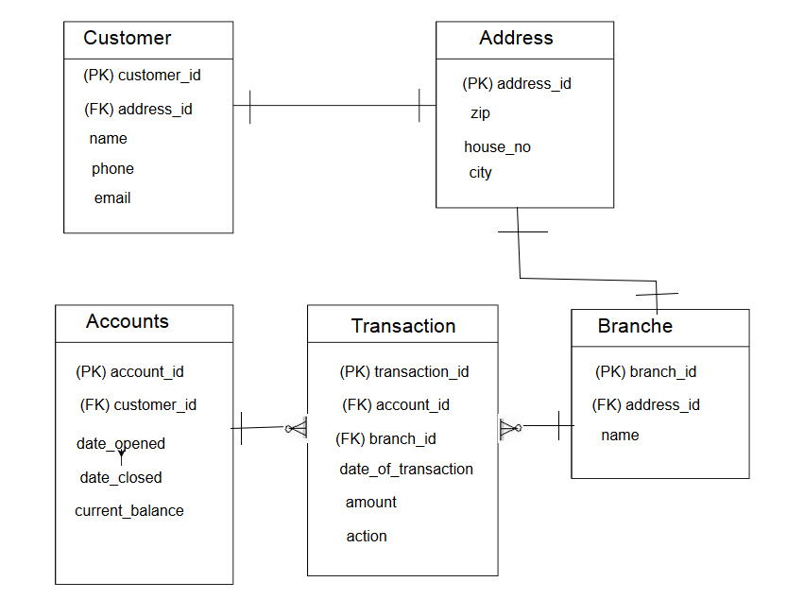

**Conclusion:**

This project will help us to understand the banking environment in a small scale, as the time span is short and we have to complete it there might be faults, we will try to complete it efficiently.